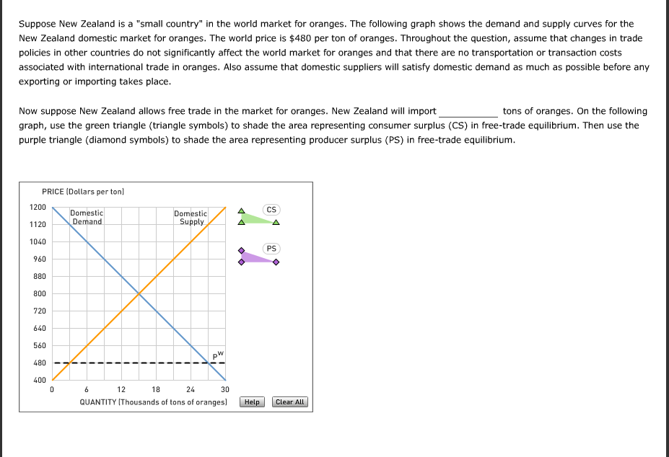
27,000
3,000
9,000
24,000
15,000

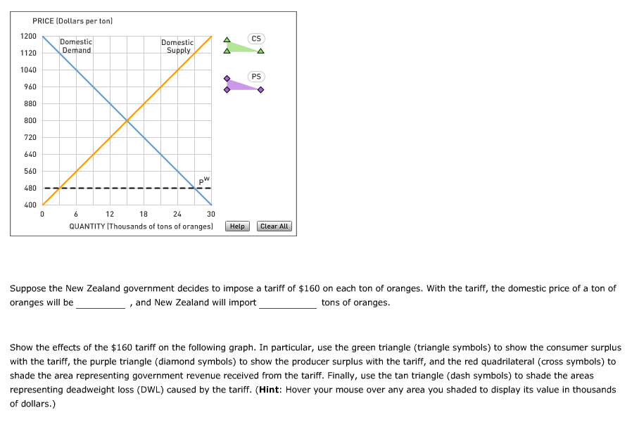
Orange will be

960
720
640
480
800
And New Zealand will import
12,000
27,000
15,000
3,000
24,000

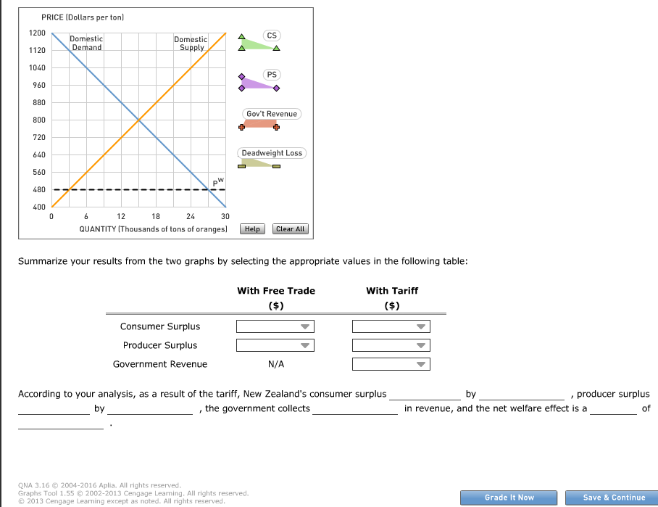

With Free Trade

6 million
120,000
9.72 million
9.84 million

120,000
9.72 million
6 million
9.84 million

With Tariff

1.92 million
1.08 million
5.88 million
6 million

5.88 million
6 million
1.92 million
1.08 million

5.88 million
3.84 million
1.92 million
1.08 million
New Zealand’s consumer surplus
increases
decreases

By:
3.84 million
960,000
1.92 million
5.88 million

Producer surplus
decreases
increases

By
960,000
1.92 million
1.08 million
3.84 million
The government collects
1.08 million
3.84 million
1.92 million
5.88 million
And the net welfare effect is a
gain
loss

of
960,000
3.84 million
1.92 million
120,000

